YOKOHAMA CURRENT ENGLISH CLUB

(YCEC was founded by the late Prof. Fumihiko Hagiwara in 1963.)

**横 浜 時 事 英 語 会**

第７０２回例会の要約です。

第７０２回例会は、石川町の労働会館４階の会議室にて、２０２３年１月

２８日（土）１時４０分から開かれました。

要約は下記の通りです。

We held our 702nd regular monthly meeting in L-Plaza at 1:40 p.m. on January 28, 2023. The summary of the regular monthly meeting is as follows:

1. Forum on current English usage
2. Shigetomi Okada （岡田　茂富）

**「YCEC Current Usage january,2023」S. Okada**

**①　ONTARIO MUNICIPAL ELECTIONS**

Tory may have just experienced his most satisfying victory. It surely wasn’t his most thrilling — that had to be winning the first time, in 2014, when so many observers figured he was done like dinner after having lost the 2007 Ontario election as PC party leader to Dalton McGuinty’s Liberals and then failing to win an ensuing byelection that would have allowed him to stay on as leader. He quit politics and moved to hosting a radio show, which many assumed would be a soft landing en route to an eventual path to the exit and out of the spotlight altogether.

-from tvo today written by Steve Paikin dated 0ct 25, 2022

■ done like dinner = 完全にやられて、打ち負かされてto be completely [defeated](https://www.collinsdictionary.com/dictionary/english/defeat" \o "Definition of defeated)

**【日本語訳】オンタリオ市長戦**

**トーリーは確かに満足すべき勝利を収めたかもしれない。だが、もっとも感激すべき勝利ではなかった。というのは２０１４年に初めて勝利したときには、２００７年にオンタリオ州の保守政党指導者としてドルトン・マックグインティー率いる自由政党に選挙で敗れた後、もう立ち上がれないほど惨敗したとみんな思っていたからである。その後彼は、引き続き行われた中間選挙にも勝利することが出来なかったが、党の指導者としてとどまるだろうと思われたのだった。トーリーは政界を去り、ラジオ番組の司会者となり、最終的にはすべてを辞め注目されなくなる方向にうまく進むものと多くの人々に思われたのである。**

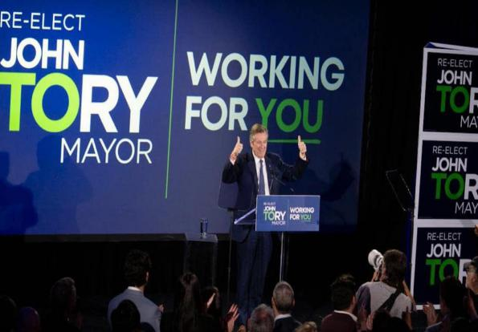 

1. ②

　　　　　Death-tech and the future of death-exlporing what it means to live and die.

②**AND FINALLY...**

From desk bombing to death-tech: If it’s corporate jargon you’re after, Raider puts some meat on the bones.　　　　-from The January 2023 issue of Insider (Media Limited)

■ desk bombing =職場で（同僚などのデスクを突然訪れ）予期せぬ質問をすること

■ death-tech = 死に関する課題をテクノロジーにより解決しようとするサービス

**【日本語訳】そして遂に**

Desk bombing から death-tech へ：求めているのが会社で使用される用語なら、レイダーが詳しく解説します。

B) Yoshikazu Miki　 (三木　義和)

1. On-brand; fitting with the image or brand or something、いかにも、あの会社らしい

Their newest commercial is so on brand that you can tell it’s for their product before you even see it.

2 Rooibos; ルイボス　（発音はロイボスに近い）

マメ科　Aspalathus属の常緑樹の総称:　南アフリカ産；葉を茶にして飲む。

3. Regroup：気持ちを取り直す。（テニスの大坂ナオミ選手のinterviewでの発言）

“The Way Champs Play” Play Academy (最近、大坂ナオミ選手が作ったテニス・アカデミー)

reorganize (as after a setback) for renewed activity

4. Itch：かゆい、やりたくてうずうずする。

a) I have an itch on my back. (背中がかゆい)

b) If I don’t play too long, I’ll get an itch. （大坂ナオミ選手のinterviewでの発言）

最近、妊娠していることを公表した。相手は、アメリカ人ラッパーのコーデー・ダンストン氏

という。

5. Busbank：バスを貸し出す会社

Group Transportation: Everything You Need To Know

When it comes to planning a group trip, deciding on what transportation your group will rely on is one of the most important decisions you will make. Air travel can get expensive really quickly and never seems to go according to plan or schedule. Carpooling is an inefficient hassle that all but ensures everyone arrives exhausted. Carpooling separates groups and makes travel disorganized. Those traveling as a group prefer to stick together; this way you avoid the risk of people getting lost and make travel a group activity that you get to enjoy together rather than an inconvenience you have to endure. With this in mind, it’s no wonder that expert group organizers turn to charter bus travel time and time again. Charter travel is comfortable, convenient, customizable, efficient, and keeps the whole group together, on schedule, and arriving recharged and ready to go! Whether you’re arranging transportation for a sports team, business, organization, school, club, big family reunion, or more, for those interested in trying out charter vehicle transportation to reduce your stress and your costs, we’ve prepared a helpful guide with everything you need to know!

1. Main speaker　　　　　　　　　　　　　　　 Hiroshi Hasegawa （長谷川　洋）

Hiroshi Hasegawa talked about Part 2 of Rishi Sunak, the first British politician of Indian descent who has served as Prime Minister of the United Kingdome and Leader of the Conservative Party since October 2022.