**\*\*\*\*\*\*\*\*\*\*\*\*\*\*\*\*\*\*\*\*\*\*\*\*\*\*\*\*\*\*\*\*\*\*\*\*\*\*\*\*\*\*\*\*\*\*\*\*\*\*\*\*\*\*\*\*\*\*\*\*\*\*\*\*\*\*\*\*\*\***

**YOKOHAMA CURRENT ENGLISH CLUB BULLETIN**

**Published Monthly by YCEC Office, with Writing and Edited by Shigetomi Okada, at Secretariat**

**YCEC was founded by the late Prof. Fumihiko Hagiwara in 1963.**

**\*\*\*\*\*\*\*\*\*\*\*\*\*\*\*\*\*\*\*\*\*\*\*\*\*\*\*\*\*\*\*\*\*\*\*\*\*\*\*\*\*\*\*\*\*\*\*\*\*\*\*\*\*\*\*\*\*\*\*\*\*\*\*\*\*\*\*\*\*\***

**２０２２年５月例会の要約です。**

**■ANNOUNCEMENT  今年５月の例会は５月２８日（土） １時４０分より開かれました。**

**TheYCEC's 695th regular monthly meeting was held on Saturday, May 28, 2022, in L-Plaza, three minutes' walk from the North exit of JR Ishikawa-cho Station.**

**▶ 695th, Sat. May 28, 2022.** **L-Plaza 第１０会議室 (９階) 　Mr. Juro 　Nakagawa（中川十郎氏）　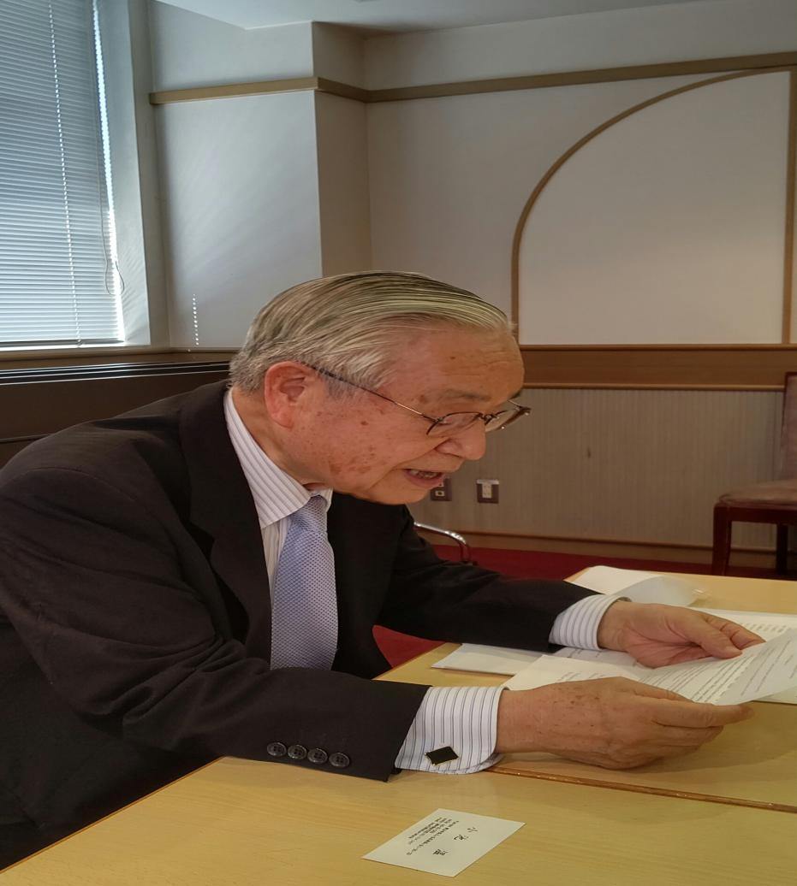**

**Topic: 「最近の国際情勢」**

　下記に発表された内容の要約を記載します。

　先生は英語で最近のウクライナ情勢の背景、没落しつつある日本の現状等について発表されました。その１部は下記のとおりです。　なお、先生のご講演に触発され、ヴァチカンについて、韓国の将来について等たくさんのご意見が提出されました。

...............................................................................................................................................

Recent International Situation and Japanese Geopolitical Strategy

Juro Nakagawa

Specially Appointed Professor, 22nd Century Institute, Nagoya City University

Director General, Chair Person, Business Intelligence Society of Japan

1. General View;

The　C0VID-19th　and　the　recent　Russian　invasion to　Ukraine have caused much trouble and uncertain situation especially in Europe, Eurasia and Asia,　which some people concerned criticized us President Biden's unproper handling of the situation and poor management of UN. The immediate stop of the conflict is much required

throughout the world.

On this occasion, Japanese LDP IS said to make the best use of the Ukraine crisis to enforce the Japanese defense capability by doubling defense budget form 1% to 2% of Japanese GDP, which shall make Japan No. 3，after the USA and China, which we should take careful attention and due consideration.

Judging from the Biden's Administration strategy, the USA is managing Ukraine crisis through NATO, by assisting the supply of weapon and military intelligence to control Russia.

In Asia, which would show the highest economic growth m the world, the US Biden Administration looks to manage to control and to make counter measure against China by protecting strategically important high technology and patents to cope with China.

For such purposes, Biden Administration recently proposed IPEF (Indo Pacific Economic Frame Work), which 13 nations expressed to participate in.

Thus, the USA is trying to control Russia through NATO and Ukraine and counter-attack China in the field of economic hegemony in Asia.

2. The Ukraine Situation.

　The USA and UN, including the Vatican showed the incapability to control Russia-Ukraine Conflict-the War.

　The Veto System of the UN made Russian Veto, which could not control Russian Invasion to Ukraine.

　It is urgently required to reform the UN to make the UN work more efficiently.

To settle the Ukraine crisis, it IS imperative to immediately start the peace negotiation including the UN and Vatican･

　They should negotiate with the spirit of Peace and Harmony, which Shotoku-Taishi in

the 6th century advised “ Wa wo motte Tottosito nasu-Peace and Harmony are most important”- The Oriental Wisdom”

3. Biden Administration's Counter-China Strategy.

　US President Biden in May visited Korea and Japan and proposed the new strategy to

countermeasure China, IPEF (Indo Pacific Economic Frame Work),which the USA will concentrate in Asia as Trump Administration left and withdrew from TPP (Trans Pacific

Partnership),which consists of 11 nations.

IPEF is targeting China by newly establishing and constructing Supply Chain especially in Asia to cope with China.

　FOIP (Free and Open Indo Pacific) , which Japan proposed might be replaced by IPEF, which 13 countries will participate in.

RCEP(Regional and Comprehensive Economic Partnership), which China is main Members, shall be further strengthened to increase trade and service in Asia - and Pacific.

TPP = CTPPT (Comprehensive and Progressive Trans Pacific Partnership), which China, UK and Taiwan, applied for membership and now is under consideration, will be important Regional Trade Agreement in Asia Pacific, which Japan should put much weight on.

Furthermore, Japan should extends her very best cooperation on APEC(Asia Pacific

Economic Cooperation) .which consists of 21 nations and region in emerging Asia Pacific in the 21st century.

　In the meantime, Japan should be more independent from the USA and must pursuit

her economic, diplomatic and defense efforts as a member of Asia and Pacific area in the 21st century.

In the meantime, Japan should be more independent from the USA and must pursuit

her economic, diplomatic and defense efforts as a member of Asia and Pacific area in the 21st century.

..........................................................................................................................................

**開室 午後１時、開会 午後1時40分**

**Fees: \500 for YCEC members, non-members, and newcomers.**

**Annual fee: \2,000 for YCEC members.**

**・第一部1:40-2:30 Forum on current English usage**

**・第二部2:40-4:10 Main speaker’s presentation**

**・第三部4:20-4:55 Speaker’s Corner: minor topics by other members**

**▶▶ 「最近の国際情勢」** Details as noted above.

■5月例会参加者１0名

**・5:15-7:00 dinner　中止**

■Current Usage for YCEC May, 2022―summarized by OKADA Shigetomi :

**AAA:　by　Shigetomi Okada**

・・・・・・・・・・・・・・・・・・・・・・・・・・・・・・・・・・・・・・・・・・・・・・・・・・・・・・・・・・・・・・・・・・

* Speakers’ Corner：

Main speaker’s presentation entails a lot of comments from the audience, leaving all but no time for Speakers’ Corner.

* 会長からのお知らせ：

高林茂先生をしのぶ会について報告がありました。

YCEC ２０２０年の会費納入者：

Ｎｏｖ．２０１９　吉田好江様　(　ｆｏｒ　２０２０）、

Ｄｅｃ．２０１９　岡田茂富 (　ｆｏｒ　２０２０）

　　　　　　　　　高島鉄城様

　　　　　　　　　都留秀之様

　　　　　　　　　三木義和様

　　　　　　　　　長谷川洋様

　　　　　　　　　久保陽様

岡田茂富記