YOKOHAMA CURRENT ENGLISH CLUB
(YCEC was founded by the late Prof. Fumihiko Hagiwara in 1963.)
横 浜 時 事 英 語 会
第７０１回例会の要約です。
第７０１回例会は１２月２４日（土）１時４０分から開かれました。

We held our 701st regular monthly meeting in L-Plaza at 1:40 p.m. on December 24, 2022. The summary of the regular monthly meeting is as follows:
- Forum on current English usage
- Shigetomi Okada （岡田 茂富）

①Proceed with caution: The trouble with trigger warnings
Trigger warnings are widely used in many universities – and increasingly, the wider world. Last year, London’s Globe theatre attached a trigger warning to Shakespeare’s Romeo & Juliet, advising it “contains depictions of suicide, moments of violence, and references to drug use,” among other things.
-from the Conversation Com of December 20, 2022
■ trigger warning = 事前警告、閲覧注意
不快な感情や記憶を思い起こす可能性がある物や事に対する警告
【訳文】 注意して進め、事前警告で揉めることがある
事前警告は多くの大学で広く使われています、さらに世界中でますます多く使われています。昨年ロンドンのグローブ劇場はシェークスピアの「ロミオとジュリエット」の上演に際し、「自殺を図る場面や、暴力をふるう時もあり、毒薬を用いる場面もある」と事前警告を発しました。

① ②
Brian Redmond
② When was the last time you cried?
I can be quite soft at times. I’m OK being connected to my emotions. People still take the mickey out of me because when Des Cahill was on Dancing with the Stars in season one, one of the weeks he did a beautiful dance number to the Marino Waltz from the Dubliners and that nearly got me going.
from: Irish Examiner of December 26, 2022
■ take the mickey out of = を馬鹿にする、からかう, make fun of (someone) 【訳文】泣いたのは何時の事
時にはひどく情に脆くなることがある。私は自分の感情に直結しても何ら構わない。人々は、依然として私を馬鹿にするが、デー・カーヒルが「スターとダンスしよう‐シーズン１」を取材していた時のこと、ある時素晴らしいダンス曲、ダブリンナーからマリノ・ワルツまでを歌ったので、私は半ばやる気を起こしたのだ。
B) Nagomi Koike （小池 温）
Word of the Year (2022)

Merriam―Webster Dictionary
gaslighting If a couple is in an abusive relationship, like in the 1938 play
“Gaslight” that inspired the English term, the act is more likely to be
mental domestic violence. （心理的虐待）

Oxford Dictionary
goblin mode A type of behavior that is unapologetically self-indulgent, lazy,
slovenly or greedy, typically in a way that rejects social norms.
(わがままで貪欲な振る舞い) 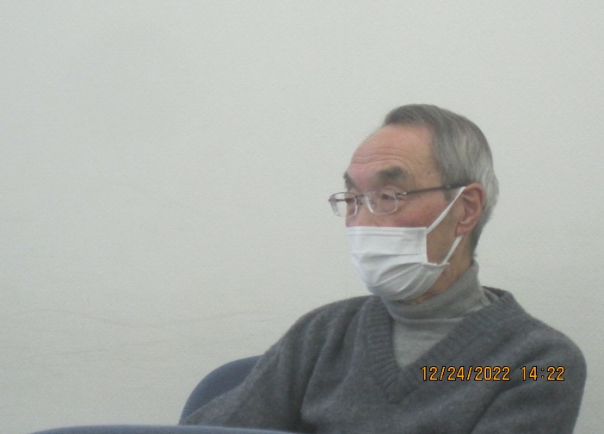

C) Yoshikazu Miki (三木 義和)
(1) Merch

New merch from Britanica!

(2) Woke:
a slang term that is easing into the mainstream from some varieties of a dialect called
African American Vernacular English (sometimes called AAVE)

Stay woke.
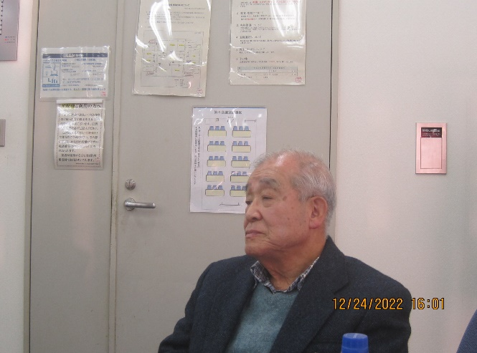

- Main speaker Hiroshi Hasegawa （長谷川 洋）

Hiroshi Hasegawa talked about Rishi Sunak, the first British politician of Indian descent who has served as Prime Minister of the United Kingdome and Leader of the Conservative Party since October 2022.
