**\*\*\*\*\*\*\*\*\*\*\*\*\*\*\*\*\*\*\*\*\*\*\*\*\*\*\*\*\*\*\*\*\*\*\*\*\*\*\*\*\*\*\*\*\*\*\*\*\*\*\*\*\*\*\*\*\*\*\*\*\*\*\*\*\*\*\*\*\*\***

**YOKOHAMA CURRENT ENGLISH CLUB BULLETIN**

**Published Monthly by YCEC Office, with Writing and Edited by Shigetomi Okada, at Secretariat**

**YCEC was founded by the late Prof. Fumihiko Hagiwara in 1963.**

**7-12月確定スケジュール暫定スケジュール,  June 27, 2021**

**\*\*\*\*\*\*\*\*\*\*\*\*\*\*\*\*\*\*\*\*\*\*\*\*\*\*\*\*\*\*\*\*\*\*\*\*\*\*\*\*\*\*\*\*\*\*\*\*\*\*\*\*\*\*\*\*\*\*\*\*\*\*\*\*\*\*\*\*\*\***

**６月例会の要約です。**

**■ANNOUNCEMENT  ６月の例会は６月２６日（土） 1時40分より開かれました。**

**The YCEC's 690th regular monthly meeting was held on Saturday, June 26, 2021, in L-Plaza, three minutes' walk from the North exit of JR. Ishikawa-cho Station.**

**▶ 690th Sat. October 26, 2021.** **L-Plaza 第4会議室 (4階) 　岡田茂富（YCEC会員）　His presentation was titled,****“Let’s Watch the Blacklist, Season 7 featuring James Spader and Megan Boone! ” and he reproduced “Rob Cain” with the voice in English and without subtitles and asked five questions: here are those questions and answers.**

1. **Who is Roy Cain?**

**① Answer： Roy Cain is the warden of the Wallens Prison.**

1. **What caused the fall of Raymond Reddington on the floor?**

**②　Answer： Wine hydrating.**

**③ For what purpose did Raymond Reddington buy a restaurant?**

**③ Answer：Because he wanted to eat a good vichyssoise.**

1. **Ruel wrote a note and gave it to Ressler. What did it say?**
2. **It said, "Wanna talk. Not here."**

I attach here below the video of Roy Cain with subtitles including English and Japanese which I think enables you to answer those questions.

**開室 午後１時、開会 午後1時40分**

**Fees: \500 for YCEC members, non-members, and newcomers.**

**Annual fee: \2,000 for YCEC members.**

**・第一部1:40-2:30 Forum on current English usage**

**・第二部2:40-4:10 Main speaker’s presentation**

**・第三部4:20-4:55 Speaker’s Corner: minor topics by other members**

**▶▶岡田茂富　“Let’s Watch the Blacklist, Season 7 featuring James Spader and Megan Boone! ”**　The elected video was titled “Roy Cain” Details as noted above.

■６月例会の**dinner** は中止。

**・5:15-7:00 dinner at すっとこどっこい045-651-7330, close to JR Ishikawa-chō Station**

■Current Usage for YCEC June 26, 2021―summarized by OKADA Shigetomi

**AAA: M. Ando** **=**  **Ranked-choice voting （優先順位付投票）**

The competition for the Democratic mayoral nomination in New York City is wide open. It’s the kind of race that **ranked-choice** **voting** is meant to help, by letting voters support their top choice without forfeiting the opportunity to weigh in on the most viable candidates – from The New York Times updated June 10, 2021.

Ranked choice voting = a voting system where, if your preferred candidate does not get enough votes to stay in the election, your vote can be given to your second choice of candidate (Cambridge Advanced Learner’s Dictionary & Thesaurus)

**BBB: S. Okada = ① stealing someone’s thunder (人の手柄を横取りする) =** Taking credit for someone else achievements.

Sorry, Venice, This Belgian City Is Stealing Your Thunder In 2021

Experts say it’s a hidden gem.

BY [ASHLEY TIBBITS](https://www.thezoereport.com/profile/ashley-tibbits-9435394" \t "_blank)

6.11.2021

Shutterstock

At long last, many people are finally getting to satiate those feelings of wanderlust they’ve had over the past year and a half. And to make up for lost time, they’re thinking big. From luxe accommodations to exotic, bucket-list locations, travelers are planning what they hope to be their most memorable trips ever.

ベニスよ、残念だったな。このベルギーの都市は２０２１年にはお株を奪うことになる。この都市は隠された宝石だとは、その筋の専門家のことばだ。

シャッターストック

やっとようやく、過去１年半にわたって旅行熱を満足させる人々が多くなりました。失われた時間を取りもどすため、人々は大きな企画をたてています。豪華な住居から、異国情緒あふれる死ぬまでに訪れたい場所まで、今までにない記憶に残る旅行をしようと計画しています。

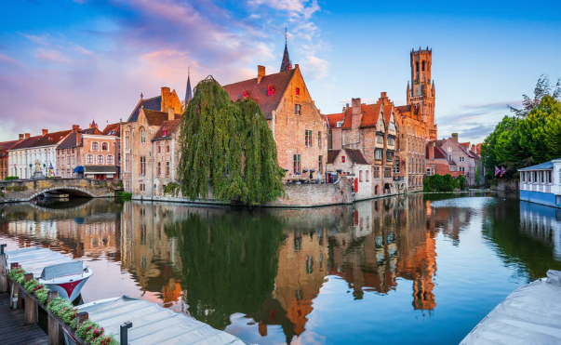　 

**■Netflix and chill**は、**『Netflixのドラマや映画を見てリラックスする』という意味ではありません**。 以前はそうでしたが、ここ数年は『誰かと寝る』の意味です。

・・・・・・・・・・・・・・・・・・・・・・・・・・・・・・・・・・・・・・・・・・・・・・・・・・・・・・・・・・・・・・・・・・

* Speaker’s Corner

Mr. Miki made his presentation on the spot asking various questions

about the English names of our body parts, animals, birds, fish and insects. For example,

1. 盲腸、2. 鼓膜、3. マントヒヒ、4. ニシキヘビ　5.　サギ　6. トキ　7. 鯛　8. 鯖　9. ムカデ　10. ゴキブリ　いくつお分かりになりましたか？

答えは　1. Blind gut 2. Eardrum 3. Sacred baboon 4. Python 5. Heron 6. Ibis

岡田茂富記